03.10.1 — Database design principles
NEXUS should start with a relational PostgreSQL schema, explicit foreign keys, transactions and carefully chosen uniqueness constraints.
The design follows these principles:
- Ownership is explicit. Every user-owned task and memory record has an identifiable owner.
- Device targeting is explicit. A task cannot accidentally migrate to another teammate's computer.
- History is durable. Task and step outcomes survive backend restarts.
- Authorization is not delegated to the model. The database stores permissions and approvals, but application code enforces them.
- Concurrent operations are expected. Constraints and transactions protect against races; Python checks alone are insufficient.
- Sensitive data is minimized. NEXUS should not persist entire documents or raw conversations when a smaller record is sufficient.
- Schema changes are versioned. Database migrations are reviewed and tested instead of being applied through ad hoc production changes.

03.10.2 — Proposed logical data model

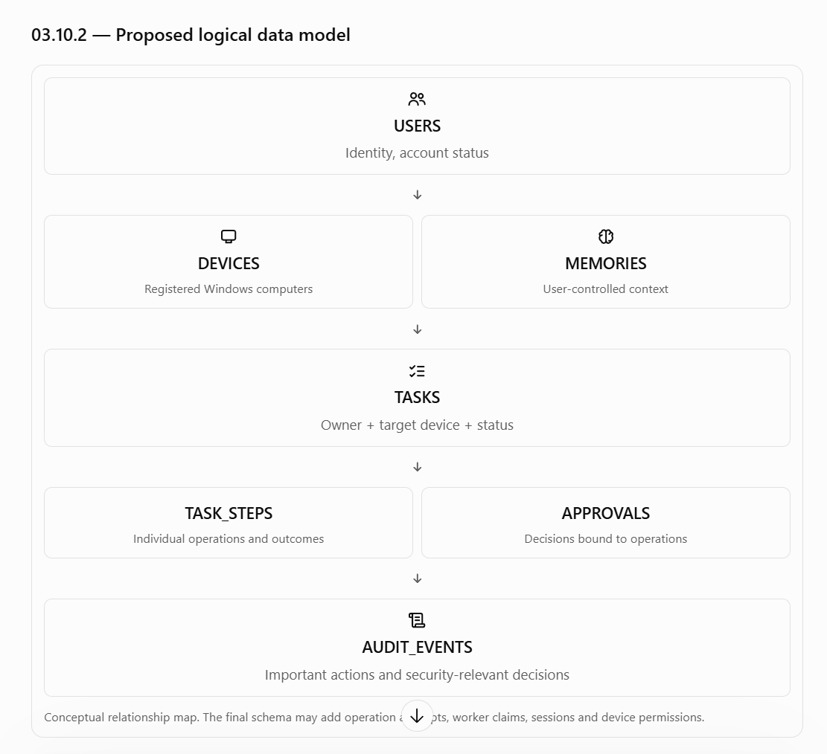

03.10.3 — Core tables

A. users
Represents a NEXUS account.
Column | Purpose
id | Primary key
username | Unique account name
password_hash | Password hash if local password authentication is selected
status | Active, disabled or another explicitly defined state
created_at | Creation timestamp
updated_at | Last update timestamp

Design rules:
- Store password hashes, never plaintext passwords.
- Do not assume a password column is required if the team chooses another authentication method.
- Disabling a user must prevent new requests and new operations.
- The policy for tasks already running when an account is disabled must be defined explicitly.

B. devices
Represents an individual Windows computer registered with NEXUS.
Column | Purpose
id | Stable device identifier
display_name | User-friendly name
owner_user_id | Account that owns the registration
status | Pending, active, revoked or another defined state
platform | Windows platform and supported version information
last_seen_at | Last successful bridge contact
created_at | Registration timestamp
revoked_at | Revocation timestamp, if applicable

Design rules:
- A device ID is an identifier, not an authentication secret.
- The bridge must authenticate independently of merely knowing its device ID.
- Revocation must be enforced at the backend and the execution boundary.
- Device ownership and task ownership must be checked together before dispatch.
- A device may appear online based on its latest heartbeat while still failing an operation; heartbeat status is not proof that every tool is available.
Open design question: can one device be explicitly shared with multiple users, or must every device have exactly one owning user? The initial proposal is one owner per registration. Shared-device access should be added only if a real use case requires it.

C. tasks
Represents one user-submitted request and its overall execution lifecycle.
Column | Purpose
id | Primary key
owner_user_id | User who submitted the task
target_device_id | Intended Windows computer
client_request_id | Client-generated idempotency key
request_text | Original request, subject to privacy policy
status | Current task lifecycle state
outcome | Final result classification, if available
created_at | Submission timestamp
started_at | First execution timestamp
completed_at | Terminal completion timestamp
updated_at | Last state change timestamp
error_code | Stable error category, if applicable

Recommended constraints:
- owner_user_id must reference a valid user.
- target_device_id must reference a registered device.
- A unique constraint on (owner_user_id, client_request_id) prevents duplicate task creation for the same user.
- Timestamps must be consistent with the task lifecycle.
- Status changes must be validated by application code; an arbitrary update must not bypass the state machine.
The request text may contain private information. Retention, access and deletion rules must be defined rather than assuming that all submitted text should be kept indefinitely.

D. task_steps
Stores the individual operations that make up a task.
Column | Purpose
id | Primary key
task_id | Parent task
step_number | Ordering within the task
tool_name | Registered tool being invoked
arguments | Validated operation parameters
status | Pending, ready, running, succeeded, failed, etc.
operation_id | Stable identifier for retries and reconciliation
attempt_count | Number of recorded attempts
started_at | Execution start
completed_at | Execution completion
error_code | Machine-readable failure category
result_summary | Minimal useful outcome

Recommended constraints:
- Unique (task_id, step_number).
- Unique operation_id.
- Every step belongs to exactly one task.
- Tool arguments must be validated against the registered tool's schema before execution.
- Result data should be bounded in size and should not automatically contain full document contents.
Important design distinction: a step and an attempt are not necessarily the same thing. If one logical operation is attempted several times, overwriting the previous attempt's details destroys useful evidence. For that reason, I recommend adding a separate task_step_attempts table.

E. task_step_attempts
Records each dispatch or execution attempt for a logical step.
Column | Purpose
id | Attempt identifier
task_step_id | Parent logical step
attempt_number | Attempt sequence
worker_id | Worker that initiated the attempt, if applicable
bridge_request_id | Identifier used for bridge-side deduplication
status | Prepared, dispatched, succeeded, failed, uncertain
started_at | Attempt start
finished_at | Attempt end, if known
error_code | Failure category
result_summary | Bounded structured outcome

Recommended uniqueness constraint: (task_step_id, attempt_number).
This table helps answer questions such as:
- Did NEXUS attempt this operation?
- Did it receive a response?
- Was the response persisted?
- Is retrying safe?
- Is there evidence that the previous attempt may have completed?
It does not magically guarantee that the bridge's filesystem operation and PostgreSQL commit happen atomically. That limitation remains part of the execution design.

F. approvals
Stores approval decisions for consequential operations.
Column | Purpose
id | Approval identifier
task_step_id | Exact operation being reviewed
requested_by_user_id | User associated with the request
decided_by_user_id | User who approved or rejected it
decision | Pending, approved, rejected or expired
operation_fingerprint | Stable representation of the approved operation
created_at | Approval request time
expires_at | Approval expiry
decided_at | Decision time

The fingerprint must cover the meaningful operation details, including the target device and relevant arguments. The exact canonicalization and hashing mechanism will be designed later.
A changed operation must not reuse an approval intended for the earlier version. The backend must revalidate the approval immediately before dispatch.

G. memories
Stores user-controlled information that can improve future requests.
Column | Purpose
id | Memory identifier
owner_user_id | Memory owner
content | Stored memory text or structured content
category | Preference, project context or another defined category
source | How the information was obtained
created_at | Creation timestamp
updated_at | Last update
deleted_at | Optional logical deletion marker

Initial design recommendation:
- Keep memory private to the owning user by default.
- Separate durable user preferences from temporary task context.
- Allow the user to inspect, update and delete memories.
- Retrieve only relevant memories for a request.
- Do not automatically convert every conversation or file into permanent memory.
- Treat model-generated inferences as uncertain unless explicitly confirmed.
- If semantic search is required, evaluate PostgreSQL full-text search first; add vector search only after choosing an embedding model and measuring its resource cost.
Logical deletion alone is not enough to meet a permanent-deletion promise. The backup, retention and any derived-index policies must be addressed in the privacy design.

H. audit_events
Records security-relevant decisions and important actions.
Column | Purpose
id | Event identifier
actor_user_id | User responsible, if applicable
device_id | Related device, if applicable
task_id | Related task, if applicable
event_type | Login, approval, revocation, dispatch, etc.
outcome | Allowed, denied, succeeded or failed
correlation_id | Identifier linking related events
metadata | Bounded, non-secret structured details
created_at | Event timestamp

Audit records should not be used as a dumping ground for complete prompts, passwords, authentication tokens or document contents.
Access to audit events must be restricted. Retention and deletion rules must be defined, especially when a user requests deletion of their task history or memory.

03.10.4 — Supporting tables and authorization data

The core tables are not sufficient by themselves to enforce every security and concurrency requirement.

Additional tables to consider

Table | Why it may be needed | Initial recommendation
device_credentials | Store device authentication material or credential references | Include if bridge authentication requires persisted credentials
device_permissions | Represent which users can operate which devices and which capabilities are granted | Include if device sharing is supported; otherwise start with owner-based access
worker_claims | Record worker ownership and lease metadata | May be represented directly on tasks or steps initially; choose one consistent model
task_events | Store a durable task progress timeline | Useful if task history needs reliable progress reconstruction
user_sessions | Support revocable login sessions | Include if the selected authentication design uses sessions or refresh tokens

Avoid creating a table simply because it sounds architecturally sophisticated. Each table should represent a real lifecycle, integrity rule or query requirement.

Ownership enforcement
Application code should check that a task belongs to the authenticated user before returning its data or permitting an action. PostgreSQL foreign keys alone do not enforce this ownership relationship.
For example, a valid task_id is not sufficient authorization to retrieve a result. The query must constrain the task by both its identifier and the authenticated user's permitted scope.
For device execution, the authorization check must additionally establish that:
- The target device is registered and active.
- The requester is permitted to use that device.
- The task is still eligible to execute.
- The requested tool and its arguments are allowed.
- Any required approval is valid and applies to the exact operation.
The bridge should enforce its own local restrictions as well. Backend authorization and bridge validation serve different trust boundaries.

03.10.5 — Relationships and integrity constraints
The intended relationships are:
- One user can submit many tasks.
- One user can register multiple devices, subject to the eventual device-sharing policy.
- One task targets one device.
- One task contains an ordered collection of steps.
- One logical step may have multiple execution attempts.
- One step may require an approval record, depending on its risk and permission policy.
- One user can own multiple memories.
- Audit events can reference users, devices and tasks where applicable.
The schema should use foreign keys for these relationships rather than relying on application conventions alone.

Deletion policy
Deletion behavior must be chosen deliberately:
- Deleting a user should not accidentally cascade into deleting security evidence that is still subject to retention requirements.
- Removing a device should revoke access and preserve relevant task history.
- Deleting a task must not automatically erase unrelated memories.
- Deleting a memory must make it unavailable to future context retrieval.
- Audit and backup retention may differ from normal application-data retention.
For the MVP, revocation or deactivation is generally safer than cascading deletion for users and devices. A dedicated data-retention policy will determine when physical deletion is appropriate.

03.10.6 — Transactions and concurrency
This is where the database model connects directly to NEXUS's execution engine.

Example A: duplicate task submissions
Two API requests arrive concurrently with the same (owner_user_id, client_request_id).
A Python-level sequence such as “check whether it exists, then insert” is unsafe: both requests can observe that the row does not exist.
The unique database constraint must arbitrate the race. The losing request should retrieve the existing task if its payload matches, or return a conflict if the payload differs.

Example B: two workers claim the same task
A worker must not simply read status = 'queued' and then update it later without coordination.
The claim should be an atomic database operation that grants ownership to one worker. A transaction with row-level locking or a carefully designed atomic update is a possible implementation. The exact query and isolation behavior should be tested against the selected PostgreSQL version.

Example C: task and step updates
When a worker records a step outcome, it may need to update both the step and the parent task.
Those database changes should be committed in a single transaction when they form one logical database-state change. The transaction should remain short and must not include waiting for the bridge to finish a Windows operation.

Example D: approval races
Suppose a user approves a step just as another process cancels the task.
NEXUS needs defined ordering and transition rules so that approval cannot accidentally revive a cancelled task. The approval endpoint and worker must re-read and validate the relevant state under appropriate transactional coordination.
Database transactions protect NEXUS's records. They do not roll back external Windows operations. This distinction must remain explicit throughout implementation.

03.10.7 — Indexing and query performance
Indexes should support actual application queries. Adding indexes to every column increases write cost and storage use, so the initial set should be small and evidence-driven.
Proposed index | Query it supports
UNIQUE users(username) | Resolve a username
UNIQUE tasks(owner_user_id, client_request_id) | Prevent duplicate task submissions
INDEX tasks(owner_user_id, created_at) | List a user's recent tasks
INDEX tasks(target_device_id, status) | Find tasks eligible for a device or worker
UNIQUE task_steps(task_id, step_number) | Retrieve ordered task steps
UNIQUE task_steps(operation_id) | Resolve an operation identity
UNIQUE task_step_attempts(task_step_id, attempt_number) | Retrieve a step's attempts
INDEX approvals(task_step_id, decision) | Resolve approval status for a step
INDEX memories(owner_user_id, category) | Retrieve a user's memories by category
INDEX audit_events(created_at) | Retrieve recent audit events
These are proposed indexes. Exact definitions should follow the final column types, access patterns and query plans. For example, a partial index for queued tasks may be beneficial if most tasks are not queued, but it should be justified by the actual worker query and measured workload.

Performance measurements
Capture a baseline for:
- Task submission latency.
- Task status lookup latency.
- Recent task history query latency.
- Worker claim latency under concurrent submissions.
- Memory retrieval latency.
- Database connection-pool saturation.
- Lock waits and transaction duration.
Do not claim database performance is acceptable based only on a few successful manual requests. The team should establish realistic test data and concurrent workloads before setting numerical service targets.

03.10.8 — Schema migrations and development workflow
Use a versioned migration tool such as Alembic with SQLAlchemy, subject to the team's final dependency decision.
The database workflow should be:
- Define the domain change and integrity requirements.
- Write a migration with a reviewable upgrade path.
- Test the migration against a fresh database.
- Test it against a database containing representative existing data.
- Verify constraints, indexes and application compatibility.
- Document how to recover if the migration fails.
- Commit migration files alongside the corresponding application change.
Do not let each developer independently modify the shared database schema through manual SQL and then try to reconstruct those changes later.
A local Docker Compose environment can provide a repeatable PostgreSQL instance. The exact PostgreSQL version, database name, credentials management, connection-pool size and migration configuration remain deployment decisions.

Test database requirements
The test suite should include:
- Fresh schema creation.
- Migration upgrade tests.
- Foreign-key and uniqueness violations.
- Concurrent duplicate submissions.
- Concurrent worker claims.
- Approval versus cancellation races.
- Task recovery after backend restart.
- Data-isolation tests between users.
- Memory deletion and retrieval tests.
Unit tests may mock the persistence interface. However, tests for transactions, locking, uniqueness and isolation must run against PostgreSQL rather than relying entirely on mocks.

03.10.9 — Data privacy and retention
NEXUS can access private documents and maintain long-term context. The data model therefore needs a privacy policy before the team implements unrestricted logging or memory capture.
Proposed defaults:
- Store only the information needed to execute tasks, recover safely and provide useful history.
- Do not store complete document contents in task records by default.
- Avoid persisting model prompts and responses unless there is a defined product need.
- Exclude secrets and authentication credentials from audit metadata.
- Keep user memories separate from task execution history.
- Make memory inspection, editing and deletion available to the owner.
- Define retention periods for task history, execution attempts and audit records.
- Document whether database backups retain deleted data and for how long.
An additional unresolved decision is whether task history is retained indefinitely, for a fixed period, or according to a user-configurable setting. This should be decided before the application advertises specific deletion guarantees.

03.10.10 — Database acceptance criteria
Use this checklist when reviewing the database implementation.

Database review
0/13
All core tables have explicit primary keys, appropriate foreign keys and documented ownership.
Duplicate task submission is prevented by a database-enforced uniqueness constraint.
Task and step states cannot be changed through unvalidated application paths.
Worker coordination prevents two valid workers from simultaneously owning the same step.
Execution attempts preserve enough evidence for safe recovery.
Approval records bind to the exact operation being authorized.
One user cannot retrieve another user's tasks, memories or unauthorized device records.
Device revocation blocks new execution while preserving required history.
Memory deletion prevents future retrieval and follows the documented retention policy.
Migrations work on both a fresh database and a representative existing database.
Concurrency and transaction tests run against PostgreSQL.
Indexes are justified by actual queries and measured access patterns.
Logs and audit metadata do not expose credentials or unnecessary private content.

03.10.11 — Decisions still open
These questions should remain visible in the design document rather than being silently settled during coding.
Decision | Why it matters
Authentication method | Determines user/session tables and credential handling
Device-sharing policy | Determines device authorization relationships
Memory search method | Affects schema, model dependencies and performance
Task-history retention | Affects privacy, storage and deletion behavior
Audit retention | Affects security investigations and deletion guarantees
Worker claim design | Determines locking, leases and stale-worker recovery
PostgreSQL version | Affects supported features and deployment consistency
Task and result size limits | Prevents unbounded database growth
Backup and restore strategy | Determines disaster recovery and deletion semantics

